REGISTRATION

1. You must first fill out the online registration form on the
website at: vacpn.net

2. The conference fees are $100 on May 16 and $100 for May 17
If you attend both days, fee is $175
Virtual attendance fees are $50 on May 16 and $50 on May 17
If you attend both days virtually, fee is $75
Fees include contact hours, breakfast and lunch each day.

This fee can be paid either online via PayPal or mailed to:
Charlie McDonough
VACPN Treasurer
9212 Shady Grove Road
Mechanicsville, VA, 23116

We are unable to accept payment at the door.

Registration deadline is
April 30, 2025.
Payment must be received by this date. We are unable to offer refunds after this deadline even if cancellations are necessary.

Non-nurses are welcome to attend our conferences, however, please note that only VACPN members can vote at our business meetings.

Overnight accommodations and dinner will be the responsibility of each participant.

Please, follow the links below for food, accommodations and fun!

Stay in Nelson County (See Popular Accommodation Options) https://nelsoncounty.com/stay

Stay in Nelson County (See Popular Accommodation Options) https://nelsoncounty.com/taste

Play in Nelson County (Explore the County's Best Activities) https://nelsconcounty.com/play



SPRING 2025 conference

May 16 & 17, 2025

End of Life Decisions and Understanding Borderline Personality Disorder and Treatment

In the parish hall of
Grace Episcopal Church
1964 Crabtree Falls Hwy
Massies Mill, VA 22967

Virtual Option offered for both sessions

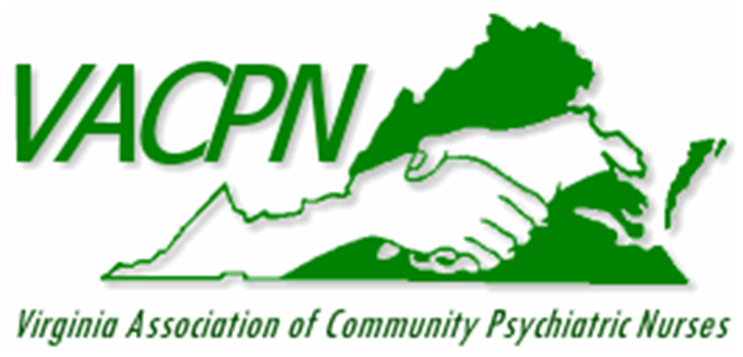

CONTINUING EDUCATION

Conference outcome:
Participants will learn about taking care of important end of life decisions including Advance Directives, spiritual and ethical decision making, the role of a death doula, organ donation and funeral arrangements. In the second session, participants will learn about borderline personality disorder and treatments and pharmacogenomics. There will also be a discussion about the scopes of practice of different levels of nursing.

Contact Hours Opportunity:

The Virginia Association of Community Psychiatric Nurses is approved as a provider of continuing professional development by the Virginia Nurses Association, an accredited approver by the American Nurses Credentialing Center’s Commission on Accreditation.

Up to 4.5 contact hours on Friday and up to 5.5 contact hours for Saturday will be awarded.

For questions/information, please contact

VACPN Co-Presidents:

Nina Beaman
Nina.Beaman@aspen.edu

Lisa Babilon
lmbabilon@henrico.k12.va.us

Friday, May 16
8:00-8:45 Registration/breakfast/welcome
8:45-9:45 Advance Directives: Nina Beaman RN-BC.
9:45-10:00 Break with Exhibitors
10:00-11:00 Spiritual and Ethical Decisions: Priest Allison
11:00-11:15 Break with Exhibitors
11:15-12:15 Death Doula: Betty Aguilar, Death Doula
12:15-1:00 Lunch and Exhibitors 45 minutes
1:00-2:00 Organ Donation: LifeNet Representative
2:00-2:15 Break with Exhibitors
2:15-3:15 Funeral Arrangements: Diana Miller, RN
3:15-3:30 Break with Exhibitors
3:30-4:00 Processing time
Dinner at local pubs on your own

May 17
8:00-8:45 Registration/breakfast/welcome
8:45-9:45 Understanding Borderline Personality Disorders: Charlie McDonough NP
9:45-10:00 Break with Exhibitors
10:00-11:00 Treatment of Borderline Personality Disorders: Lindsay Moffett NP
11:00-11:15 Break with Exhibitors
11:15-12:15 Pharmacogenomics: Rosie Taylor Lewis NP
12:15-1:15 Lunch and Exhibitors
1:15-2:15 Clinical Issues Facilitated Discussion
2:15-2:45 Processing time
2:45-3:00 Break with Exhibitors
3:00-4:30 Business meeting

